Notice of the South African National Rowing Championship Regatta 2025

- Venue
Alan Francis Rowing Course, Roodeplaat Dam, Pretoria - a straight 1000m/2000m course of 8 lanes.

- Date and Time
Saturday 26 April 2025 and Sunday 27 April 2025. Starting at 8am both days.

- Events
This regatta is open for all Clubs to enter crews in the events listed on the schedules attached with proposed starting times, status and distance indicated. Racing will be run under the approved RowSA Rules of Racing and specific Local Rules, with SAROC members officiating.

Composite and Junior Crews are encouraged to enter.
Medals for 1st 2nd and 3rd place in all A/ 1st div events. A bronze medal will be given to the winners in B and C events

Championship events are assigned by the RowSA Executive. Any changes from the original list made after the posting of this Notice will be advised to you.

The ORDER OF EVENTS will be those shown in the list of events BELOW, and entries should be made accordingly. Heats and some Master events will be run IN THE MORNINGS with finals IN THE AFTERNOONS ON BOTH DAYS as per the order of events AND DEPENDING ON ENTRIES.

- Entries
Entries should be made on the Internet. The site address is www.regatta.co.za.
For those entering a regatta via the Internet for the first time, please contact Gaynor du Toit on email at row@rowsa.co.za (cell 082 570 4932) to obtain a username and password. Gaynor will also help with the entry of composite crews.

Please note that full crews are required when making entries, and all rowers must be registered (with photograph) with RowSA on the www.regatta.co.za website. Any club experiencing problems should contact Gaynor du Toit (row@rowsa.co.za or 0825704932) before the regatta. This procedure replaces the necessity for individual rowers to carry their own ID cards.

Entries close at 17:30 MONDAY 14 April 2025 in order for RowSA to do a first draft draw and establish the events that will be run.

The draft draw will be distributed on 16 April 2025 and will be published on the website. The draw will be seeded where possible. Alphanumeric Bow numbers will be used at this regatta.

Late entries will be accepted up to 17 April 2025 but solely at the discretion of the Organising Committee. The Final Draw will be published on 22 April 2025.

Entries made on the internet are regarded as you automatically accepting the Entry Indemnity Conditions.

Late entries will NOT be accepted on Regatta days.

- ENTRY FEES

Entry Fee is R50.00 per event per competitor (excluding coxswains). International crews will be guests of Rowing South Africa.

A spectator fee of R50/day will be charged. Spectators will need to buy entry tickets before they arrive. The ticket system will be shared in due course.

All people passing through the Roodeplaat Dam Reserve entrance will be charged their entry fee for cars and trailers unless you have pre purchased a season ticket.

Seat Entry Fees should be deposited directly into:-
RowSA Current account:-
FNB Parktown
Branch Code 25 04 55
Account # 588 1551 6910
And a copy of the deposit slip emailed row@rowsa.co.za Invoices will be raised once the draw is closed.

- TRAINING

Crews must use the course in strict observance of the Traffic Rules included in this package. Please note that the course will be closed to crews training from 30 minutes before the first race until cleared by the President of the Jury after the last race of the day.

NOTE : TrainING: -- UP - Lanes 1-3; DOWN - Lanes 6-8; safety lanes - Lanes 4 & 5.

- RACE DISTANCE : HEATS AND FINALS (refer RowSA Rule 29.2)

2000m : All Open Championship, Lightweight & A Events.
2000m : All B, J16 and J18 Events
1000m : All C and J15 Events
1000m : All Masters Events – All heats will be classed as finals for Master races

- ADDITIONAL RACING RULES

-The number of heats, and semi-finals if required, will depend on the entries received by 14 April 2025.
-Some lightweight events are offered, but if the entries are low, LW races will be combined with HW races. The World Rowing weight restrictions will be enforced, and anyone not complying with the World Rowing weight restrictions will race as open weight competitors.
-Masters: No medals will be awarded to competitors where there are less than 2 entries per event. All masters age categories will be extracted from the regatta entry system. Please make sure that the date of birth is correct on the entry system.
-Competing clubs must have registered a full description of their Tri-suit/T-shirt and blade colours with RowSA.
.
- PLEASE OBSERVE THE ORDER OF FINALS WHEN MAKING ENTRIES.
THE RESPONSIBILITY FOR ENSURING THAT NO CREW, BLADE OR BOAT CLASHES OCCUR RESTS WITH THE CLUB.
THERE WILL BE NO CHANGES TO THE ORDER OF EVENTS AS PUBLISHED IN THIS PACKAGE.

- Trailers are to be parked next to the St Albans shed or outside the enclosure next to the trailer parking area.
No trailers must be parked on the roads.

- A Prize-Giving Ceremony will be held 30 mins after the last race of the regatta on Sunday.

Yours in Rowing,

Gaynor Du Toit
RowSA Administrator
26 March 2025

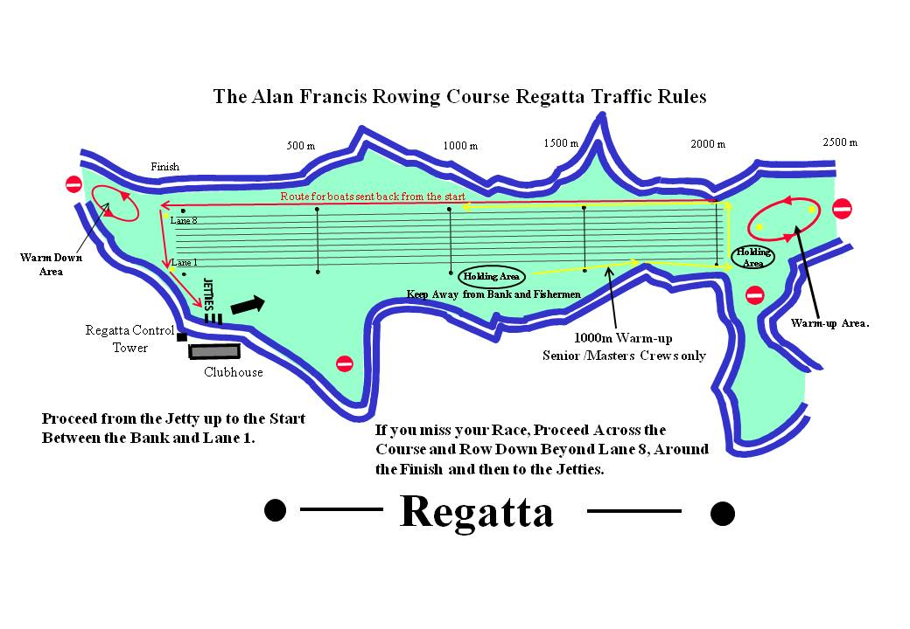

SA NATIONAL CHAMPIONSHIP REGATTA PROPOSED RACE SCHEDULE 2025

Event No. | Event | Distance | Time |  | Event No. | Event | Distance | Time
 | Saturday |  |  |  |  | Sunday
 | Heats | 08:00 to | 12:00 |  |  | Heats | 08:00 to | 12:00
1 | Masters 4- | 1000 | 12:00 |  | 45 | MA 1X LW | 2000 | 12:00
2 | MA 2x | 2000 | 12:06 |  | 46 | MA 1x | 2000 | 12:06
3 | WA 1x LW | 2000 | 12:12 |  | 47 | WA 2x LW/HW | 2000 | 12:12
4 | WA 1X | 2000 | 12:18 |  | 48 | MB 4x- | 2000 | 12:18
5 | JM18 2- | 2000 | 12:24 |  | 49 | Mast W 1x | 1000 | 12:24
6 | JW18 2x | 2000 | 12:30 |  | 50 | Mast 2nd Div 2- | 1000 | 12:30
7 | WC 4-/+ | 1000 | 12:36 |  | 51 | JM18 2x | 2000 | 12:36
8 | MC 4x-/+ | 1000 | 12:42 |  | 52 | JW18 2- | 2000 | 12:42
9 | JW16 4+ | 2000 | 12:48 |  | 53 | WC 4x/+ | 1000 | 12:48
10 | MB 2x | 2000 | 12:54 |  | 54 | MC 4-/+ | 1000 | 12:54
11 | JW15 4x+ | 1000 | 13:00 |  | 55 | JW16 8+ | 2000 | 13:00
12 | JM15 8x+ | 1000 | 13:06 |  | 56 | JM16 4+ | 2000 | 13:06
13 | WB 1x | 2000 | 13:12 |  | 57 | Mast 2ndDiv 8+/8x+ | 1000 | 13:12
15 | Mast 1stDiv 2x | 1000 | 13:18 |  | 58 | WB 2x | 2000 | 13:18
16 | Mast 3rdDiv 1x | 1000 | 13:24 |  | 59 | JM15 4x+ | 1000 | 13:24
16 | JM18 1x | 2000 | 13:30 |  | 60 | JW15 2x | 1000 | 13:30
17 | JM16 8+ | 2000 | 13:36 |  | 61 | MB 1x | 2000 | 13:36
18 | MB 8+ | 2000 | 13:42 |  | 62 | Mast 1stDiv 1x | 1000 | 13:42
19 | JW16 2x | 2000 | 13:48 |  | 63 | JW18 1x | 2000 | 13:48
20 | LTA Mix4+ | 1000 | 13:54 |  | 64 | WB 8+ | 2000 | 13:54
21 | ASM 1x/ ASW 1x | 1000 | 14:00 |  | 65 | JW16 2- | 2000 | 14:00
22 | Mast 2ndDiv 4x | 1000 | 14:06 |  | 66 | JM16 2- | 2000 | 14:06
23 | MA 2- LW/HW | 2000 | 14:12 |  | 67 | Mast W 4x | 1000 | 14:12
24 | Mast W 2x | 1000 | 14:18 |  | 68 | Mast 3rdDiv 8x+/8+ | 1000 | 14:18
25 | WA 4x- | 2000 | 14:24 |  | 69 | WA 2- | 2000 | 14:24
26 | JM16 2x | 2000 | 14:30 |  | 70 | MA 4- | 2000 | 14:30
27 | JW15 1x | 1000 | 14:36 |  | 71 | Masters 1stDiv 2- | 1000 | 14:36
28 | WB 4- | 2000 | 14:42 |  | 72 | Mast mixed 4x | 1000 | 14:42
29 | WC 1x | 1000 | 14:48 |  | 73 | JM15 1x | 1000 | 14:48
30 | JM15 2x | 1000 | 14:54 |  | 74 | MC 1x | 1000 | 14:54
31 | MC 8+ | 1000 | 15:00 |  | 75 | MB 4- | 2000 | 15:00
32 | Mast 2ndDiv 1x | 1000 | 15:06 |  | 76 | Mast 2ndDiv 2x | 1000 | 15:06
33 | Mast 1stDiv 4x- | 1000 | 15:12 |  | 77 | WC 8+ | 1000 | 15:12
34 | MB 2- | 2000 | 15:18 |  | 78 | WB 2- | 2000 | 15:18
35 | JW18 4+ | 2000 | 15:24 |  | 79 | JM16 1x | 2000 | 15:24
36 | JW16 1x | 2000 | 15:30 |  | 80 | JW16 4x+ | 2000 | 15:30
37 | JM16 4X+ | 2000 | 15:36 |  | 81 | Mast 3rdDiv 2x | 1000 | 15:36
38 | JM18 4x+ | 2000 | 15:42 |  | 82 | JM18 4+ | 2000 | 15:42
39 | Mast 3rdDiv 4x | 1000 | 15:48 |  | 83 | JW18 4x+ | 2000 | 15:48
40 | Mast Mixed 2x | 1000 | 15:54 |  | 84 | MC 2x | 1000 | 15:54
41 | WC 2x | 1000 | 16:00 |  | 85 | Mast 1stDiv 8+ | 1000 | 16:00
42 | MA 4x | 2000 | 16:06 |  | 86 | WB 4x- | 2000 | 16:06
43 | JW18 8+ | 2000 | 16:12 |  | 87 | WA 4- | 2000 | 16:12
44 | WA 8+ | 2000 | 16:18 |  | 88 | JM18 8+ | 2000 | 16:18
 |  |  |  |  | 89 | MA 8+ | 2000 | 16:24

